OUTPUTS:

1. DISPLAY SCREEN:

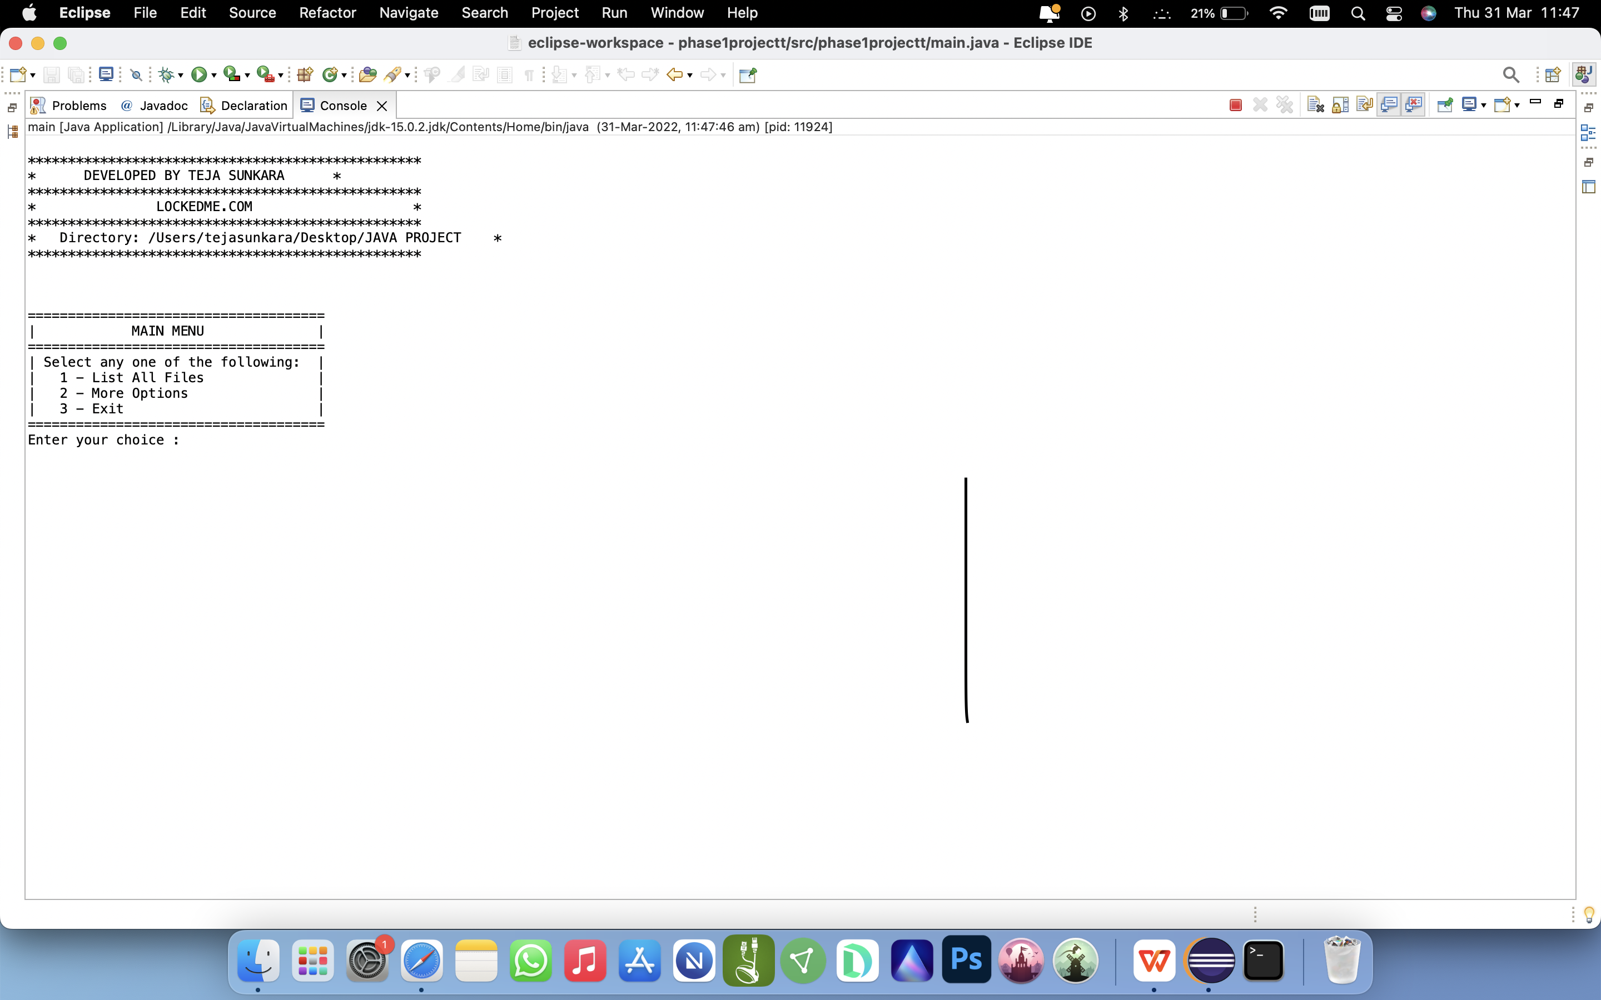

1. LISTING ALL FILES IN THE DIRECTORY:

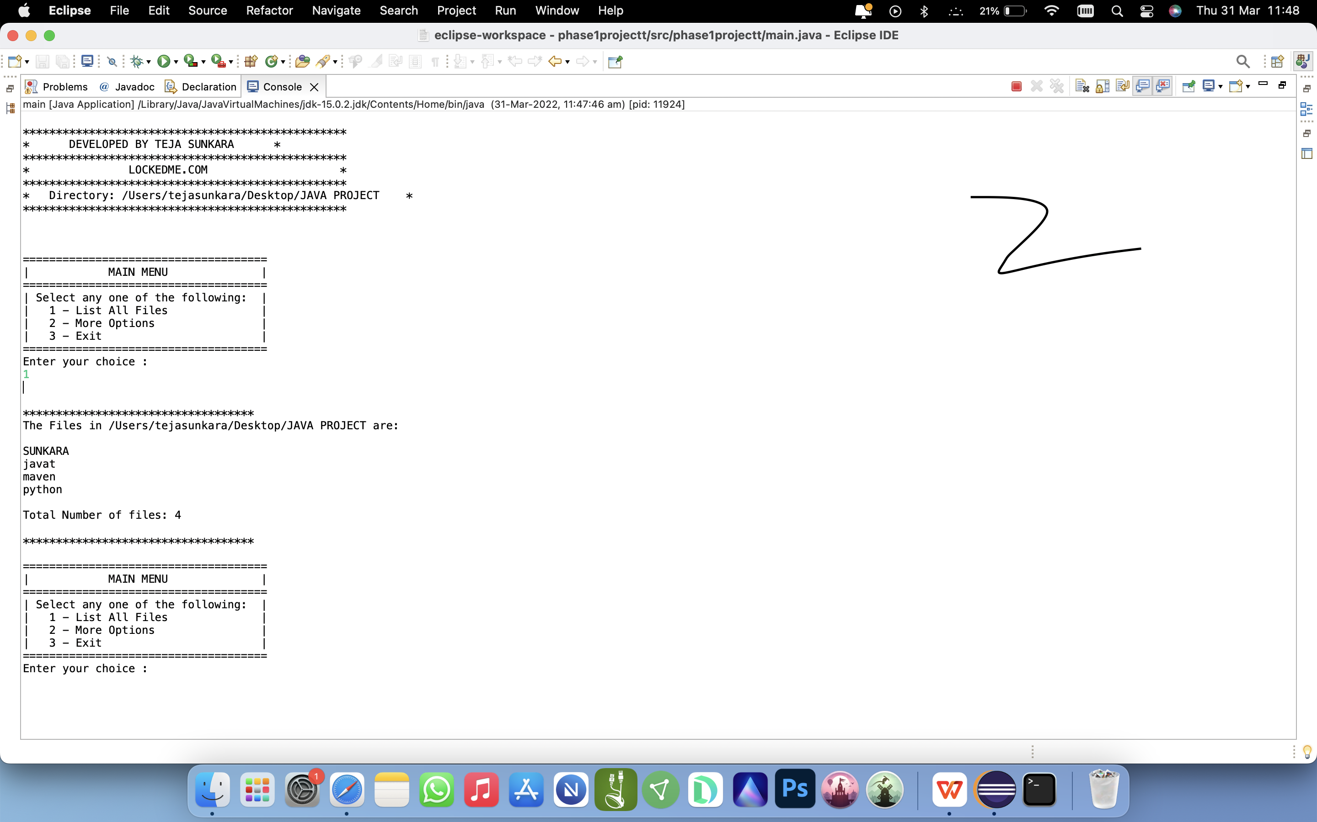

1. ADDING FILES TO THE EXISTING REPOSITORY:

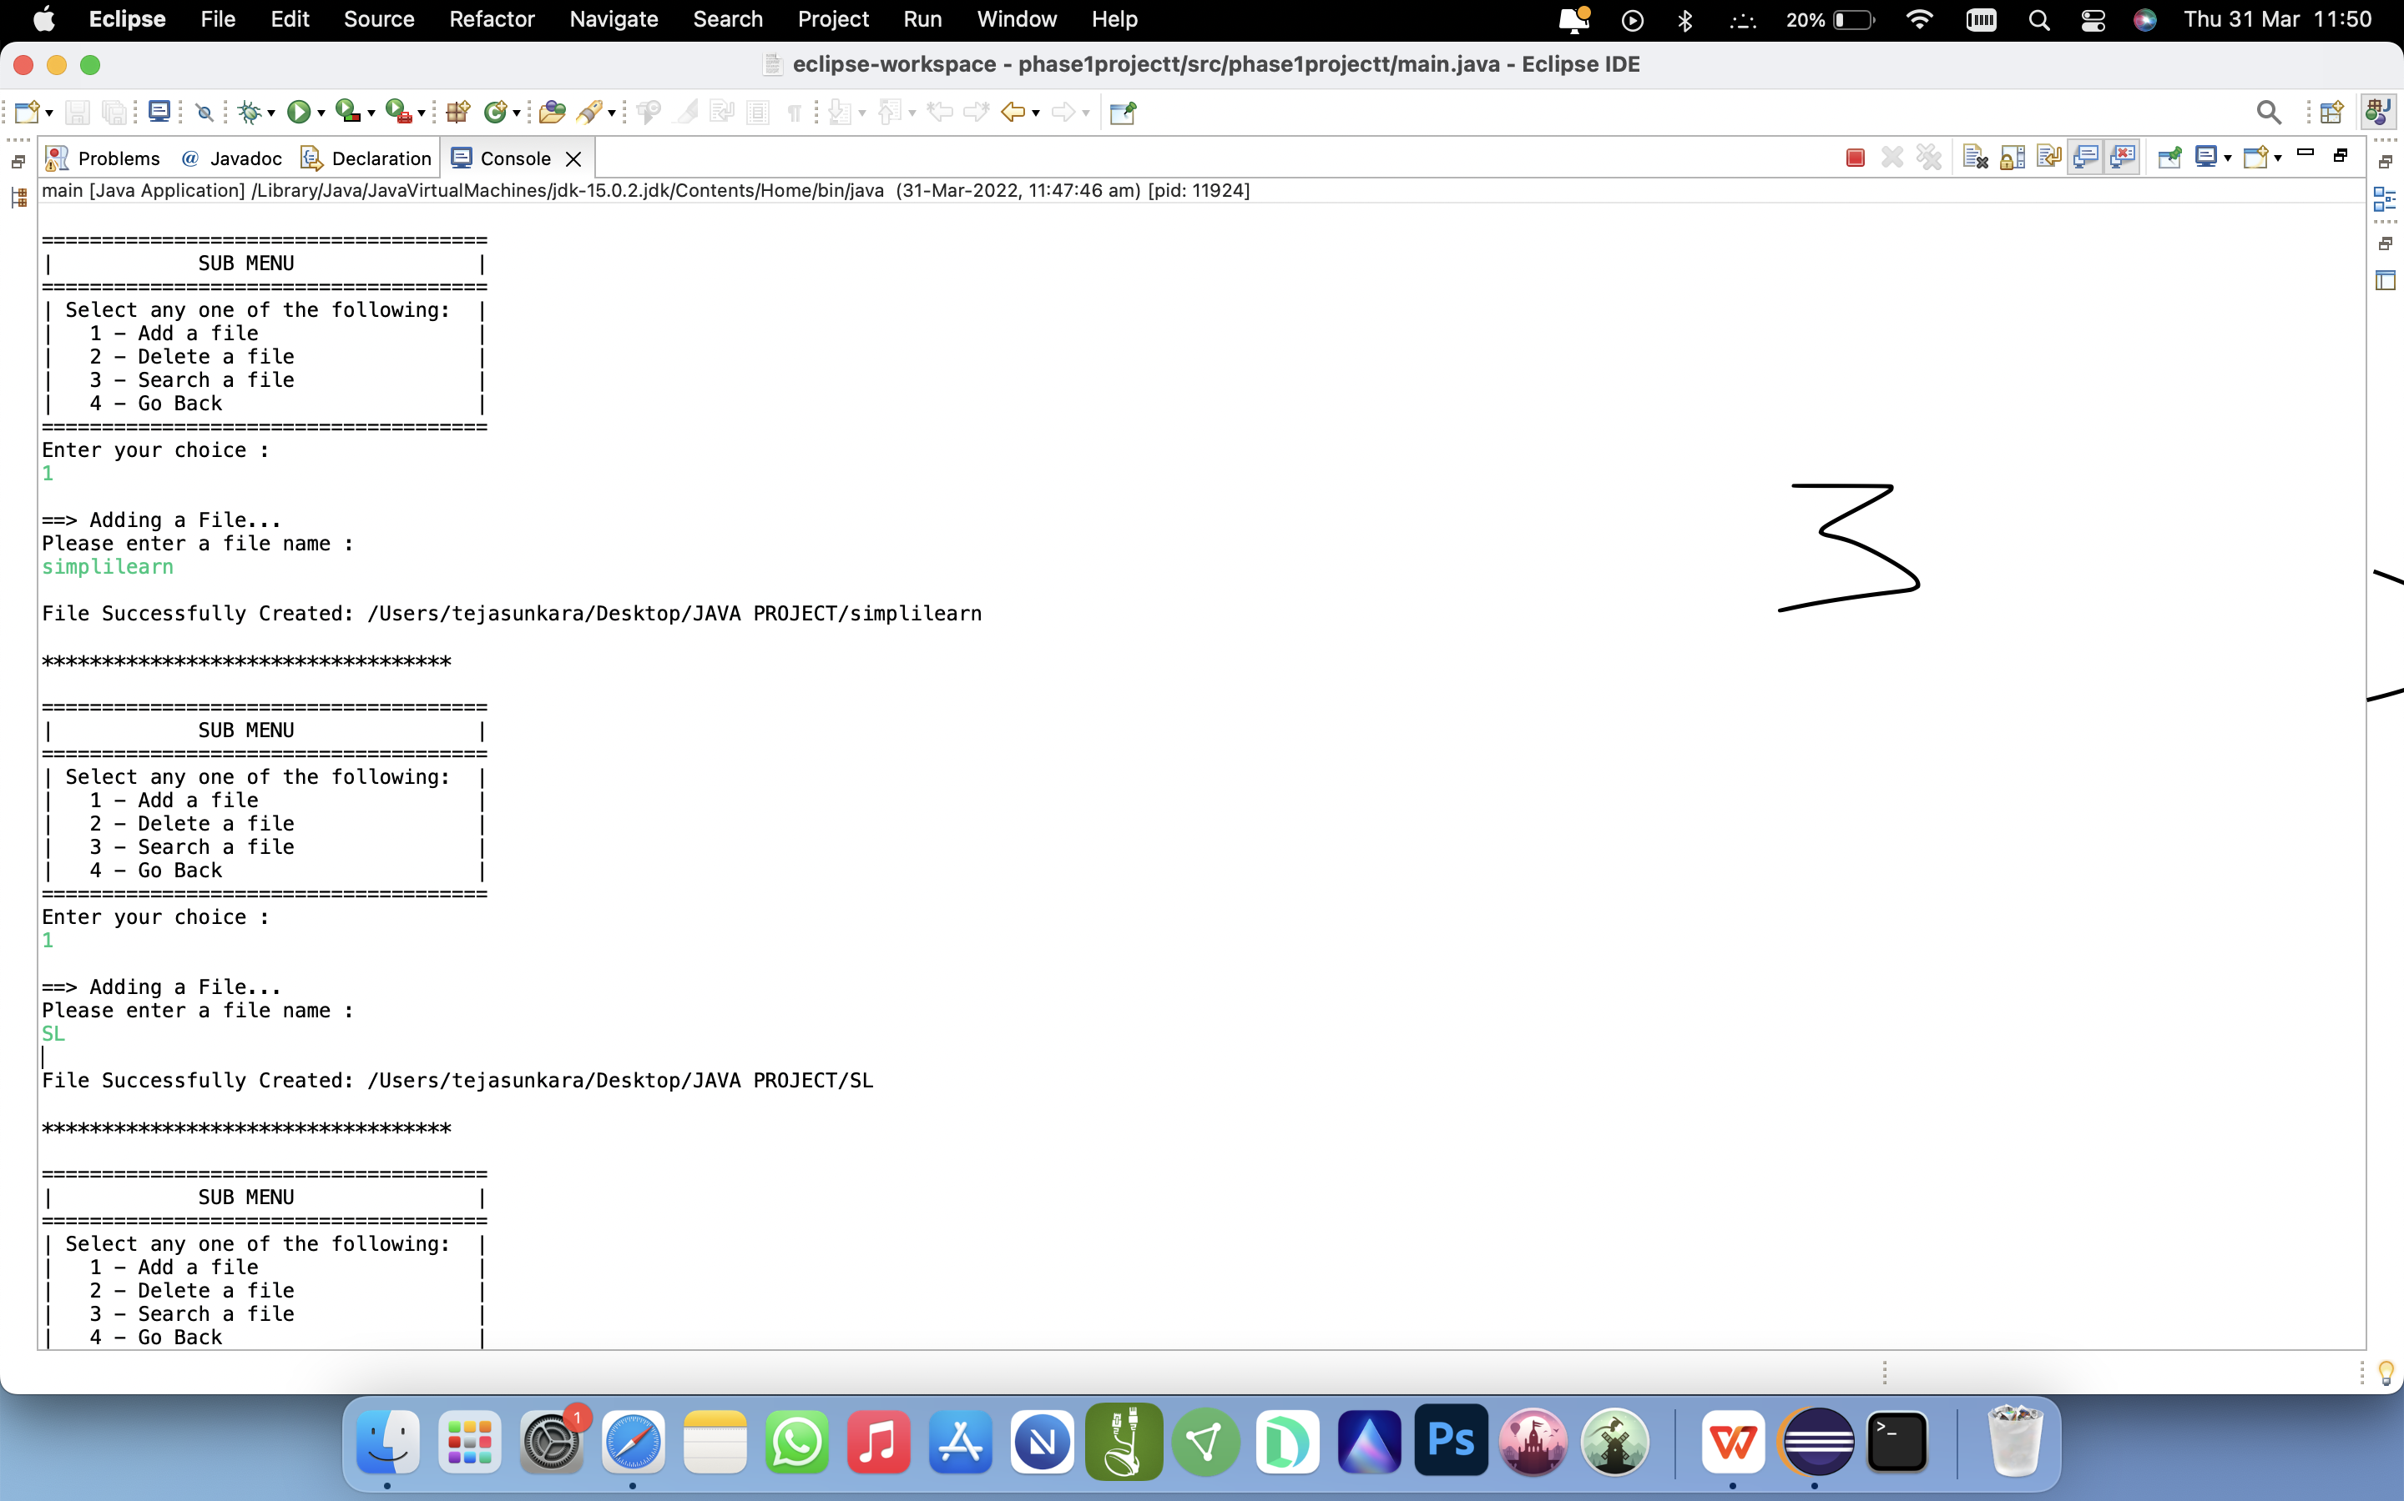

4. DELETING A FILE IN THE DEPOSITORY:

4.1: DELETING A FILE IF FOUND:-

4.2: DISPLAYING A MESSAGE IF NOT FOUND:-

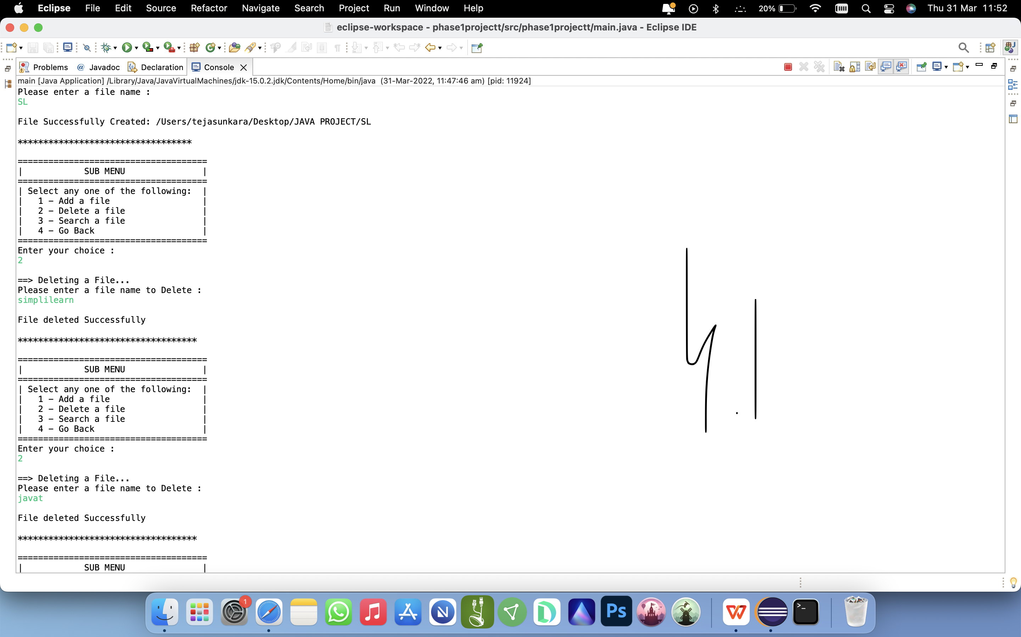

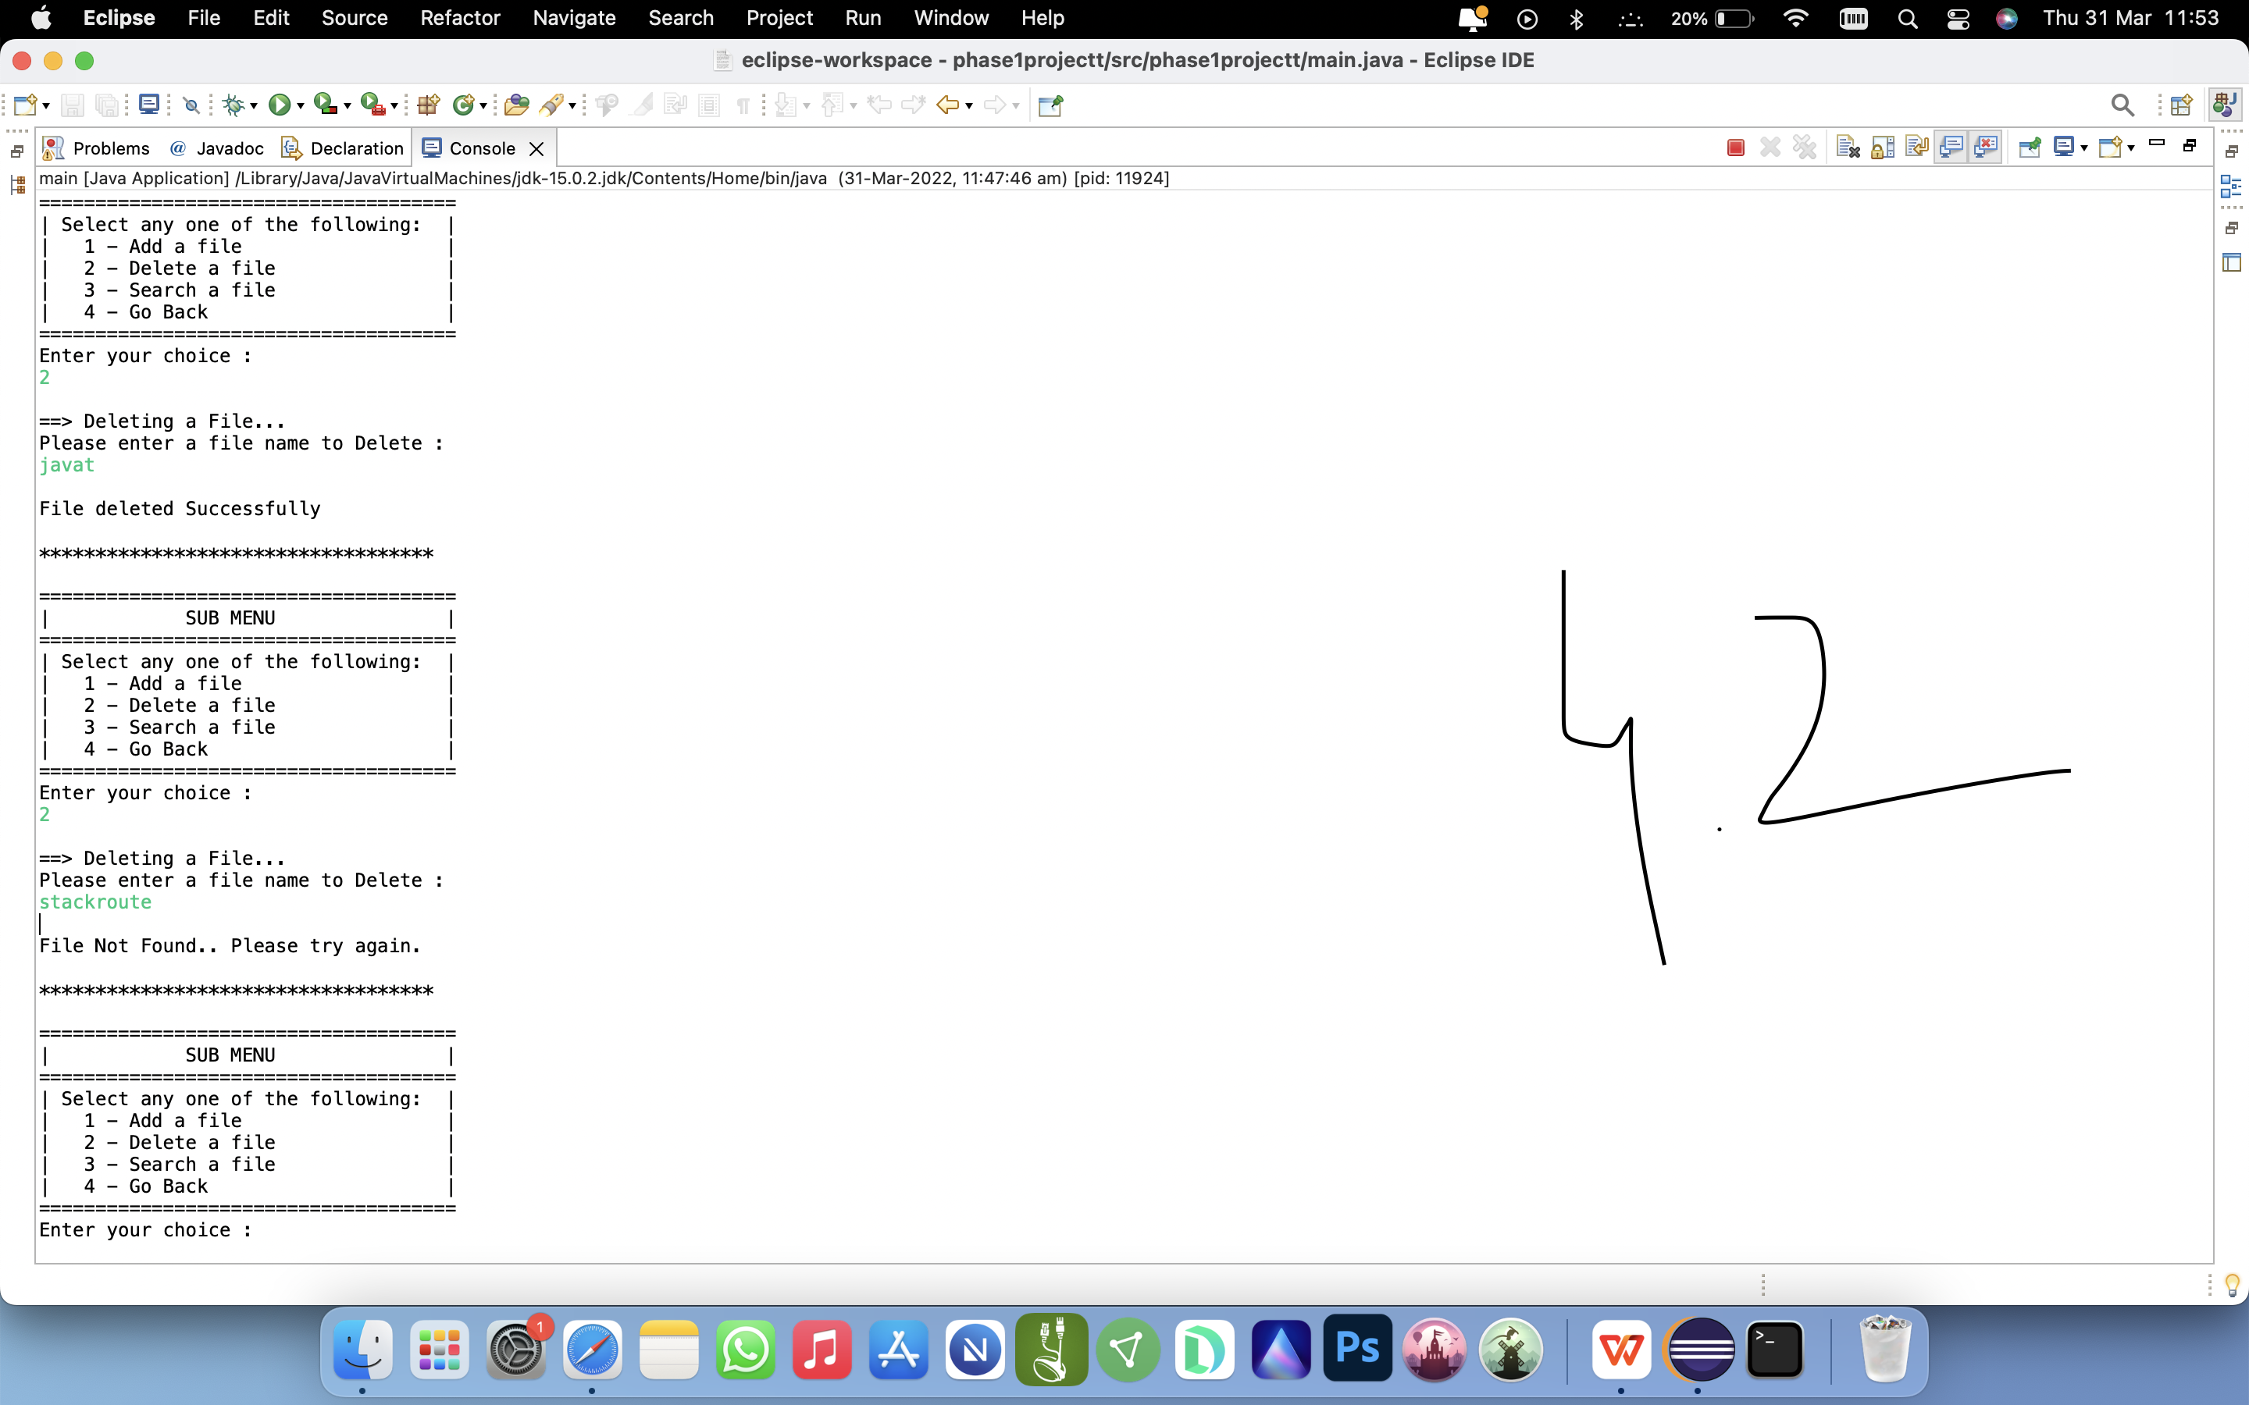

1. SEARCHING A FILE

5.1: SEARCHING A FILE IF FOUND:-

5.2: DISPLAYING A MESSAGE IF NOT FOUND:-

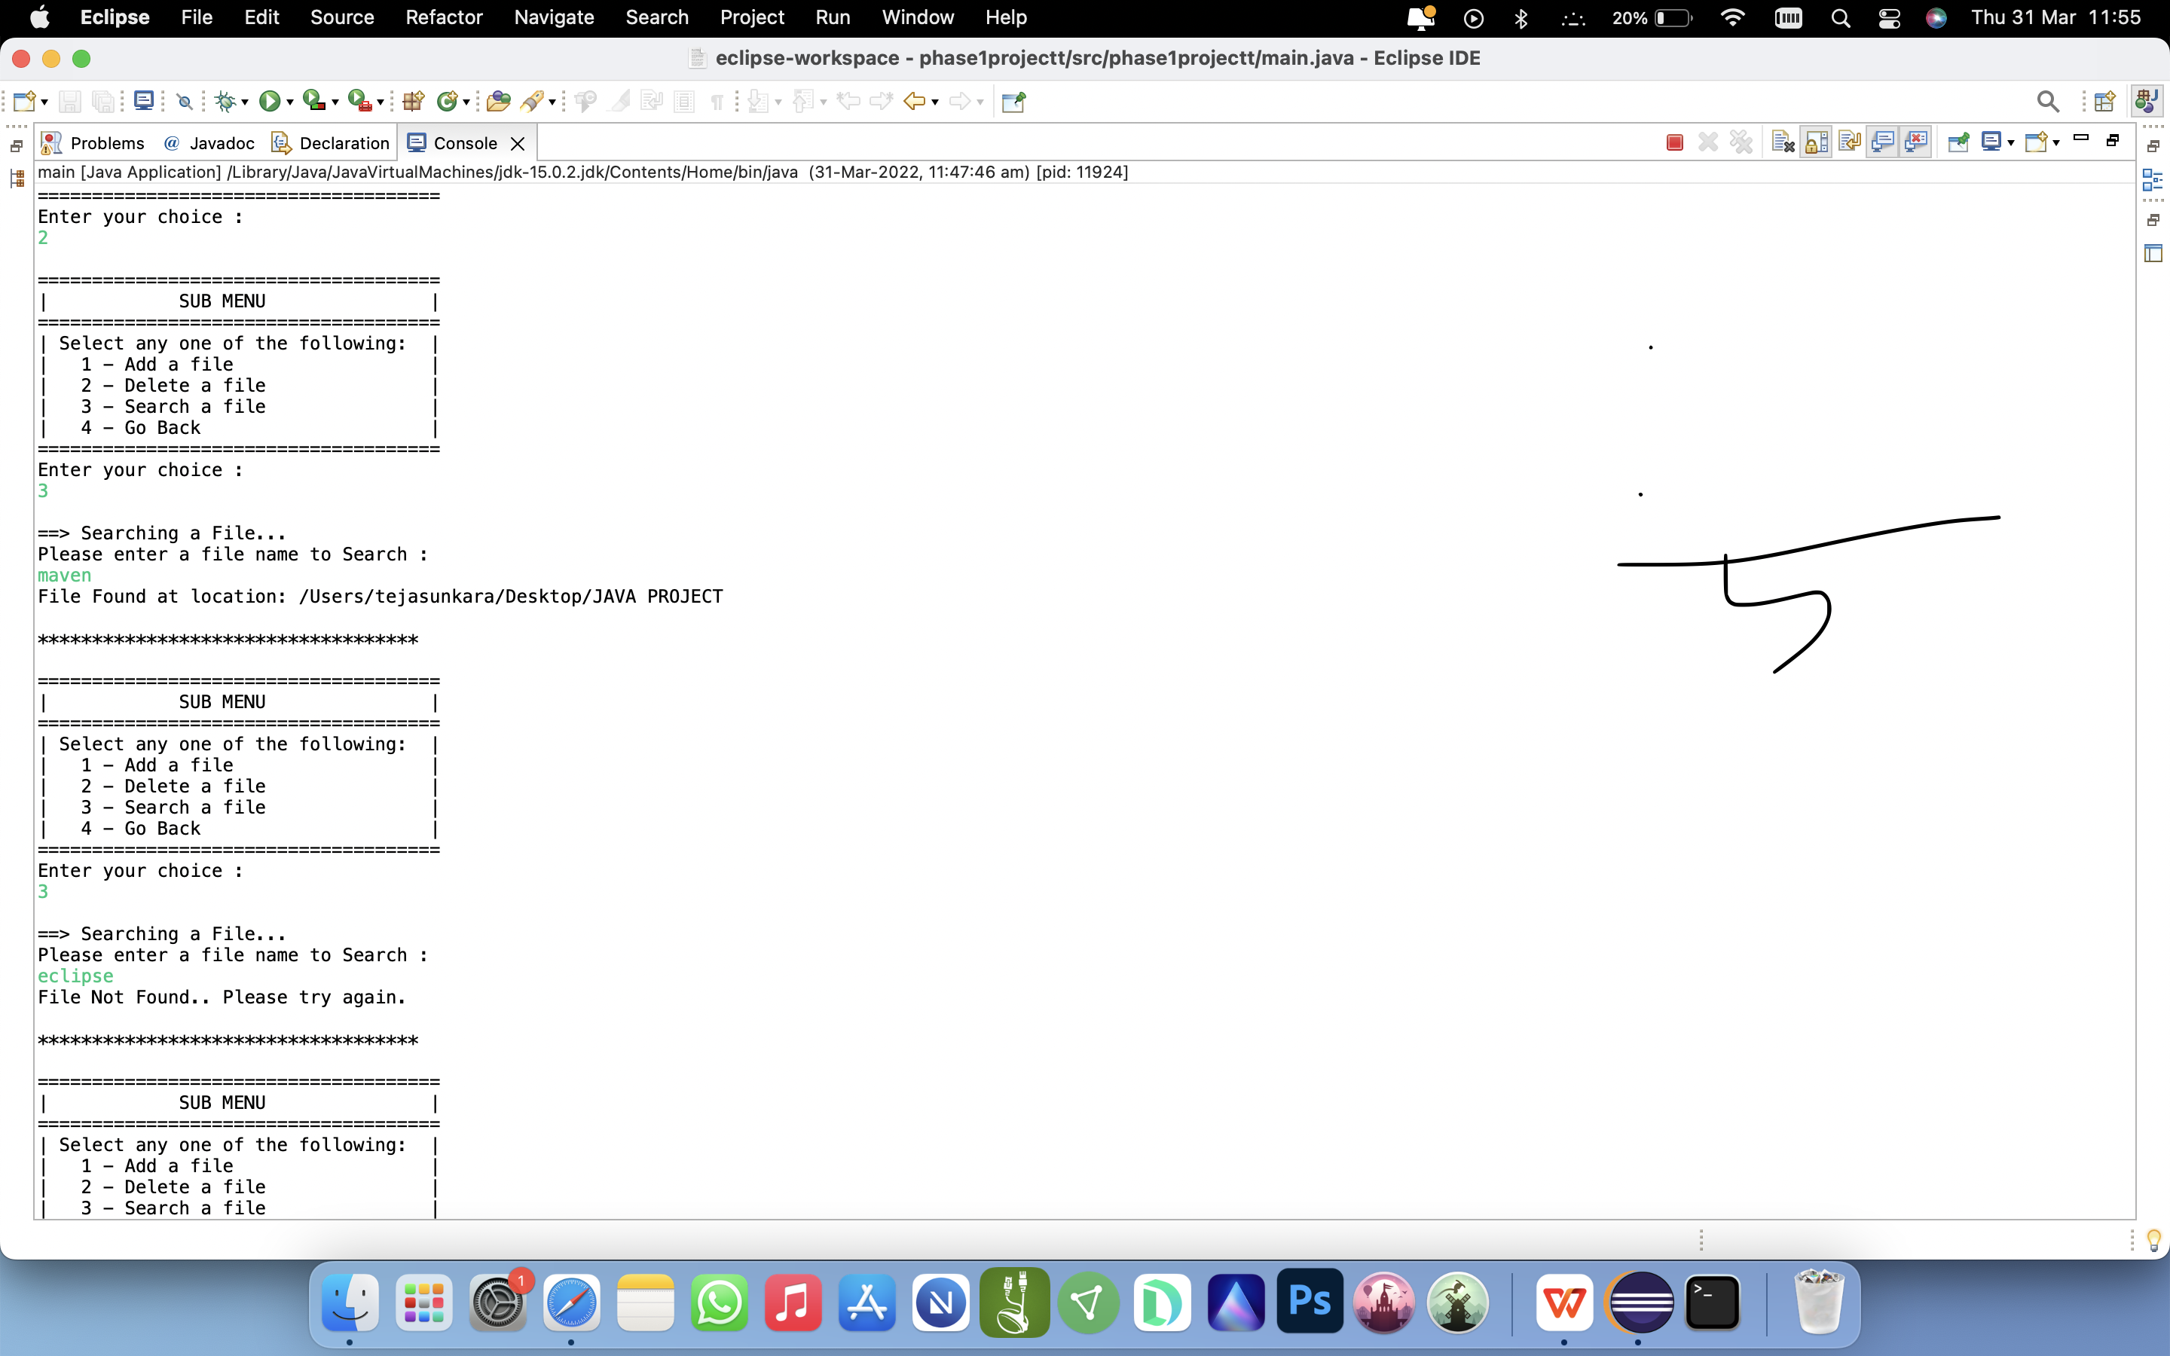

1. SORTING ALL FILES IN ASCENDING ORDER:

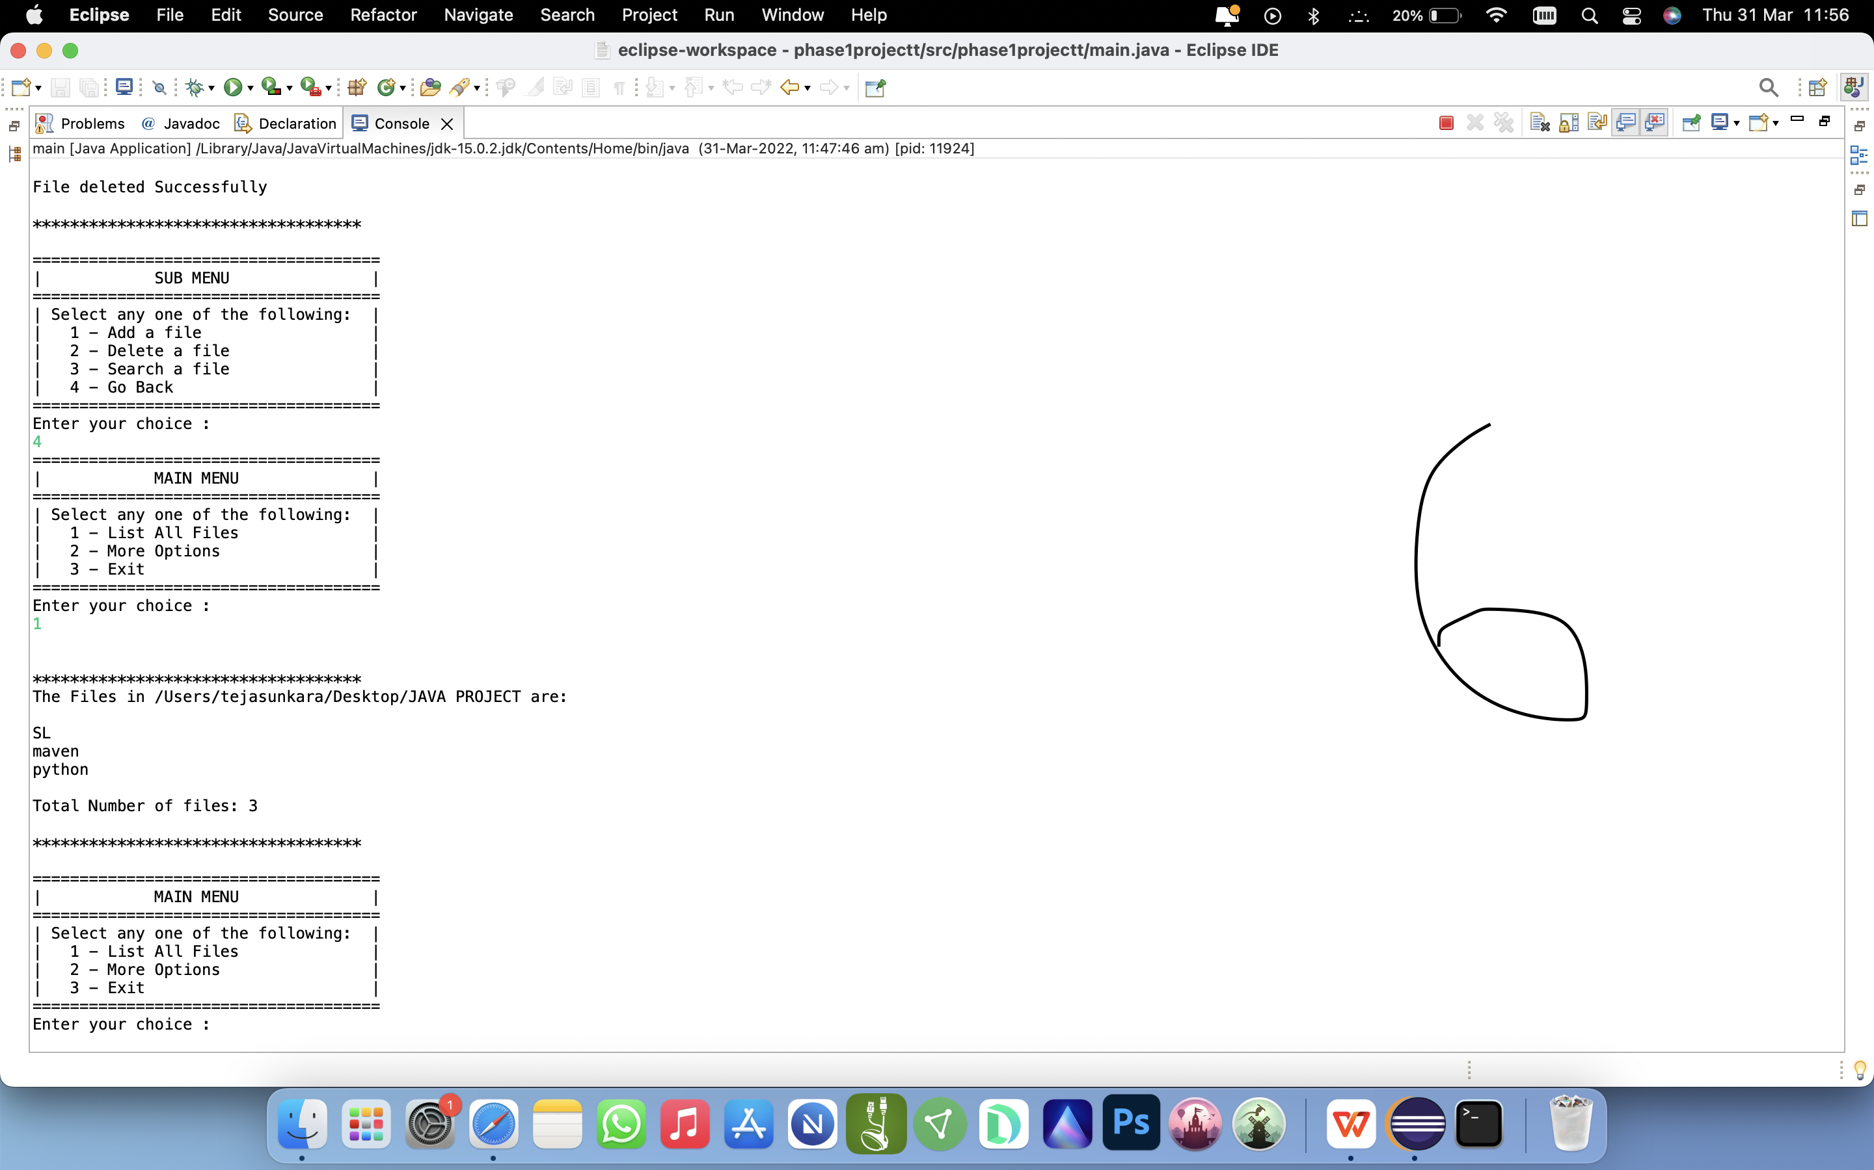

1. EXITING THE PROGRAM:

